7) Find name of sailors whose name begins and ends with B and has at least 3 characters.

**QUERY-**

SELECT SAILOR.SID, SAILOR.SNAME FROM SAILOR

WHERE SAILOR.SNAME LIKE ‘B_%b’;

**OUTPUT-**

8) Find names of sailors whose name begins and ends with B and has exactly 3 chars.

**QUERY-**

SELECT SAILOR.SID, SAILOR.SNAME FROM SAILOR WHERE SAILOR.SNAME LIKE ‘B_%b’;

**OUTPUT-**

9) Display all names (including duplicates) of sailors who have reserved a red boat or a green boat.

**QUERY-**

SELECT SAILOR.SNAME FROM SAILOR,RESERVE,BOAT

WHERE SAILOR.SID=RESERVE.SID AND RESERVE.BID=BOAT.BID AND (BOAT.COLOR='red' OR BOAT.COLOR='green')

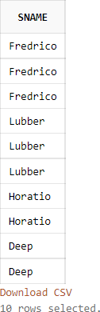**OUTPUT-**

10) Find names of sailors who have reserved a red boat or a green boat.

**QUERY-**

SELECT SAILOR.SID,SAILOR.SNAME FROM SAILOR,BOAT,RESERVE

WHERE SAILOR.SID=RESERVE.SID AND BOAT.BID=RESERVE.BID AND BOAT.COLOR='red'

UNION

SELECT SAILOR.SID,SAILOR.SNAME FROM SAILOR,BOAT,RESERVE

WHERE SAILOR.SID=RESERVE.SID AND BOAT.BID=RESERVE.BID AND BOAT.COLOR='green';

**OUTPUT-**

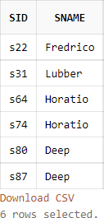

11) Find names of sailors who have reserved a red boat and a green boat.

**QUERY-**

SELECT SAILOR.SID,SAILOR.SNAME FROM SAILOR,BOAT,RESERVE

WHERE SAILOR.SID=RESERVE.SID AND BOAT.BID=RESERVE.BID AND BOAT.COLOR='red'

INTERSECT

SELECT SAILOR.SID,SAILOR.SNAME FROM SAILOR,BOAT,RESERVE

WHERE SAILOR.SID=RESERVE.SID AND BOAT.BID=RESERVE.BID AND BOAT.COLOR='green';

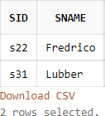**OUTPUT-**

12) Find names of sailors who have reserved a red boat but not a green boat.

**QUERY-**

SELECT SAILOR.SID,SAILOR.SNAME FROM SAILOR,BOAT,RESERVE

WHERE SAILOR.SID=RESERVE.SID AND BOAT.BID=RESERVE.BID AND BOAT.COLOR='red'

MINUS

SELECT SAILOR.SID,SAILOR.SNAME FROM SAILOR,BOAT,RESERVE

WHERE SAILOR.SID=RESERVE.SID AND BOAT.BID=RESERVE.BID AND BOAT.COLOR='green';

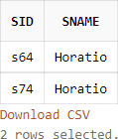**OUTPUT-**